UCPATH – UC Payroll, Academic Personnel, Timekeeping, Human Resources
UCPath Training – Laying the Groundwork for a Smooth Transition
As we move toward rolling out UCPath, the UC ANR UCPath Project Team will be providing guidance and training to all employees so they can move forward confidently when UCPath goes live in March.
Tools & Training That Will be Available
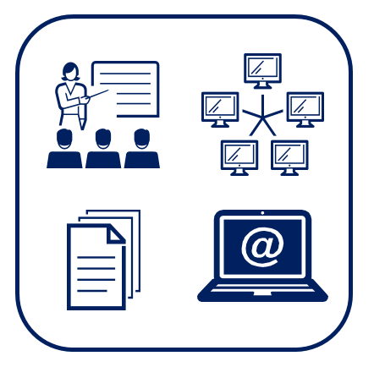
UCPath glossary – Help with terminology that may be unfamiliar at first.
Job aids – Visual guides that will help employees and supervisors complete specific tasks.
UC Learning Center (Learning Management System/LMS) – The UC Learning Center is a resource for hundreds of instructor-led and eLearning activities. It can also provide supervisors with solutions for managing and tracking required courses for their direct reports.
UPK (User Productivity Kit) Simulations – Simulation module that provides step-by-step instructions on how to perform transactions in UCPath.
Courses are self-paced, so you can view a topic multiple times and/or skip topics you are familiar with or wish to view later.
You can choose how to view a particular topic:
- “See it”: View page layout
- “Try it”: Simulate reviewing and/or entering information into the page
- “Print it”: Print step-by-step instructions on how to review and/or enter information
So, what is next?
UCPath training materials will be made available for all employees shortly. Our goal is to have all departments fully up to speed prior to go-live, confident in using the UCPath system and knowledgeable about where to find help when it is needed.
“The UC ANR UCPath Training Team is ready and constantly working with the UCPath Central Team and other UC Locations’ Training Teams. I encourage you to reach out as needed. If you have ideas on how UCPath can serve you better, please let us know. The door is always open.”
- Sree Mada

Be Sure to Visit and Browse UC ANR UCPath Training

A variety of resources are available on ucpath.ucanr.edu to help you transition to UCPath with confidence. New courses and training materials are scheduled to upload frequently in the coming weeks, so come back often. As resources are updated on a regular basis, they are best viewed online rather than downloaded and saved to your computer or a shared drive.
Employee Self Service video (https://youtu.be/quA41WFQOEQ)
Manager Self Service video (https://youtu.be/Dkw6ZqY1l20)

Have Questions?
For questions about logging into or navigating the UC Learning Center, signing up for courses, or technical difficulties participating in courses, please do not hesitate to contact ucpath@ucanr.edu.

